

**Tobor**

Email automation

Detailed Process Description

Version 0.1

Revision History

|  |  |  |  |
| --- | --- | --- | --- |
| **Date Issued** | **Version** | **Description** | **Author** |
| 12/06/2020 | 0.1 | Draft | Premal Nayee |
| *Date* | *Version Number* | *Draft / Final etc.* | *Name* |
| *Date* | *Version Number* | *Draft / Final etc.* | *Name* |

Contributors

The content of this document has been authored with the combined input of the following group of key individuals.

|  |  |  |
| --- | --- | --- |
| **Name** | **Role** | **Area** |
| Roberto Fernandez | Application Manager and Project PM | Backend / Tobor Inc |
| *Name* | *Job Title* | *Dept / Company* |
| *Name* | *Job Title* | *Dept / Company* |

Business Sign-off

The following table contains the people required to sign-off and/or review this document and those that require the document for information only.

|  |  |  |
| --- | --- | --- |
| **Name** | **Department** | **Responsibility** |
| Roberto Fernandez | Application Manager and Project PM | Backend / Tobor Inc |
| *Name* | *Department* | *Information / Sign off / Review* |
| *Name* | *Department* | *Information / Sign off / Review* |

Document Classification

|  |  |
| --- | --- |
| **Classification** | Company Confidential |
| Definition | Information is company confidential and needs to be protected |
| Context | Where loss of information confidentiality would result in significant harm to the interests of the Organisation, financial loss, embarrassment or loss of information |
|  |  |

Contents

1 Introduction 4

2 Manual Process 4

2.1 Overview 4

2.2 Detailed Process Flow 4

3 Automation Proposal 4

3.1 Overview 4

3.2 Automated Process Flow 4

3.3 Target Systems & User Requirements 4

3.4 Impacted Business Areas 5

3.5 Workload 5

3.6 Operational Constraints 5

3.7 Delivery 5

3.8 Contact List 5

4 Automation Details 6

4.1 Automation Walkthrough 6

4.1.1 *First robot action* 6

4.1.2 *second robot action* 6

4.1.3 *third robot action etc.* 6

4.2 Reporting 6

4.2.1 Business Exceptions 6

4.2.2 System Exceptions 6

4.2.3 Performance 7

4.2.4 Triggers 8

# 1 Introduction

*Background to the situation and an overview of the opportunity for automation.*

Tobor Inc has recently released a new app which has generated more users than expected. The process of adding new users is labour some so much so that the backend application manager is spending approximately 50% of his day. The process of adding new users requires obtaining information from emails and manually entering the user’s details into the internal systems. After which the users periodically receive content.

# 2 Manual Process

## 2.1 Overview

*Overview of the manual process as it stands currently. Includes bullet pointed list of high-level steps to take to run the process.:*

* Step 1: Look through outlook inbox (“QATesting545@outlook.com”), sort emails by the action to be carried out and add each request to user CRUD queue
* Step 2a: With the emails that are asking to add user, then extract fields from emails and add user to the content delivery database
* Step 2b: With the emails that are asking to remove or update user details, then extract the relevant fields and make the necessary changes to the internal system
* Step 3: Daily web scrape content websites (sport, tech and hobbies) for articles to present to users
* Step 4: Periodically send unique emails to users on their requested content type

## 2.2 Detailed Process Flow

*Detailed flow diagram covering* ***all*** *steps in the current manual process*

User imitation

Aggregation and distribution

User Administration

Aggregate content from different sites and store to database

Sort the QA mailbox for user requests, by the action that should be taken

Web scrape user details from bestrandoms.com

Send emails from that imitate the registering of each user

Send users content based on their preferences

Add/Update user details to the database

# 3 Automation Proposal

## 3.1 Overview

*High level overview of the proposed automation, including detail around the type of automation*

The process will be automated using UiPath. It will include integration with MS outlook and will be scheduled to run every day. It will scrape web pages daily for content on to give to users and will associate a unique ID with each article.

## 3.2 Automated Process Flow

*If the automation process flow adheres to the manual process flow above, there is little need to duplicate. A statement to that effect should suffice, confirming all actions will be automated. Otherwise, a detailed flow should be presented.*

Manual process will be automated where each step will run as an independent process, periodically executed in a queue in UiPath Orchestrator.

## 3.3 Target Systems & User Requirements

|  |  |  |
| --- | --- | --- |
| Name | Description | User Permissions/Access |
| MS Outlook | Email Inbox | Robot will require read/write access to the QA mailbox to send and receive emails to everyone in the office. Cannot change UI. |
| Gmail | Email provider | Robot will require read/write access to the QA mailbox to send and receive emails to everyone in the office. Cannot change UI. |
| Bestrandoms.com | Fake name generator | Generates random names and addresses. Cannot change UI. |
| News.google.com | New aggregation website, use to easily scrape the websites ("Sky Sports", "BBC Sport", "Yahoo Sports", "TechRadar", "MIT Tech Review", "TechCrunch", "Cycling Weekly", "Motorcycle News", "DIY Magazine") | Robot will require read access to the web page HTML content. |
| Excel | Report are generated from UiPath’s queues and exported to PDF using Excel | A valid Microsoft Excel account is required and permission to read/write files in the reports folder of the project. Also UiPath needs access to Excel to carry out the automation. |

## 3.4 Impacted Business Areas

* *Department / Areas affected by the automation*
* Mostly backend team will notice the difference
* Users may notice requests will be fulfilled quicker

## 3.5 Workload

*Metrics related to the automation, table example below*

|  |  |
| --- | --- |
| Number of Users | 547 |
| Range of users joining per week | 10 - 50 |
| Average number of users joining per week | 25 |
| Are there any periods when a higher workload is anticipated? | Around major news stories and sporting events |

***Summary of average time process takes a user to run manually, include timings of any dependant parts such as responses coming back from 3rd parties.***

***Automating the steps below will realise an average time saving of 4 hours per day or 20 hours per week for the administration of users and distribution of content:***

* Adding, updating or deleting users based on the email requests – 1 hour
* Sending each user aggregated content based on their preferences – 2 hours

*Aggregate – Find articles from multiple news websites*

## 3.6 Operational Constraints

* *List of all operational constraints. Examples could be working hours, system availability etc. – essentially anything that could have a bearing on how the automation can function.*
* Processes will run daily in a queue using UiPath Orchestrator
  + Each process will run at specified times so that processes run linearly
* Automation will be built using UiPath Studio Pro
* Data will be stored as CSV for easy adaptability to company systems
* Daily reports will be made to PDF format for easy viewing
* The cut-off for users to be added to the content delivery database is 11:30 am

## 3.7 Delivery

*The time scale for the development, testing and delivery of this project. In the early stages this may indicate the timescale is to be finalised.*

An MVP is expected by 29/06/20. After which work will begin on integrating the automation to the backend of the app.

## 3.8 Contact List

*List of key contacts for the project, both QA Ltd and Client e.g.*

*David Bradbury – Managing Director*

*Roberto Fernandez – Backend Application Manage and Project PM*

[*Robert.toborinc@gmail.com*](mailto:Robert.toborinc@gmail.com)

*Chris Lucas – Consultant Project Liaison*[*chris.lucas@qa.com*](mailto:chris.lucas@qa.com)

*Premal Nayee - Consultant*  
[*pnayee@qa.com*](mailto:pnayee@qa.com)

# 4 Automation Details

## 4.1 Automation Walkthrough

### Create the fake user database and mimic users requests

The creation of the fake user database will be automated. Users request will be carried out manually for simplicity

* Create fake user database
  + First navigate to bestrandoms.com/random-names (see below)
  + Type into the quantity box
  + Click Generate
  + Copy all the names from the webpage

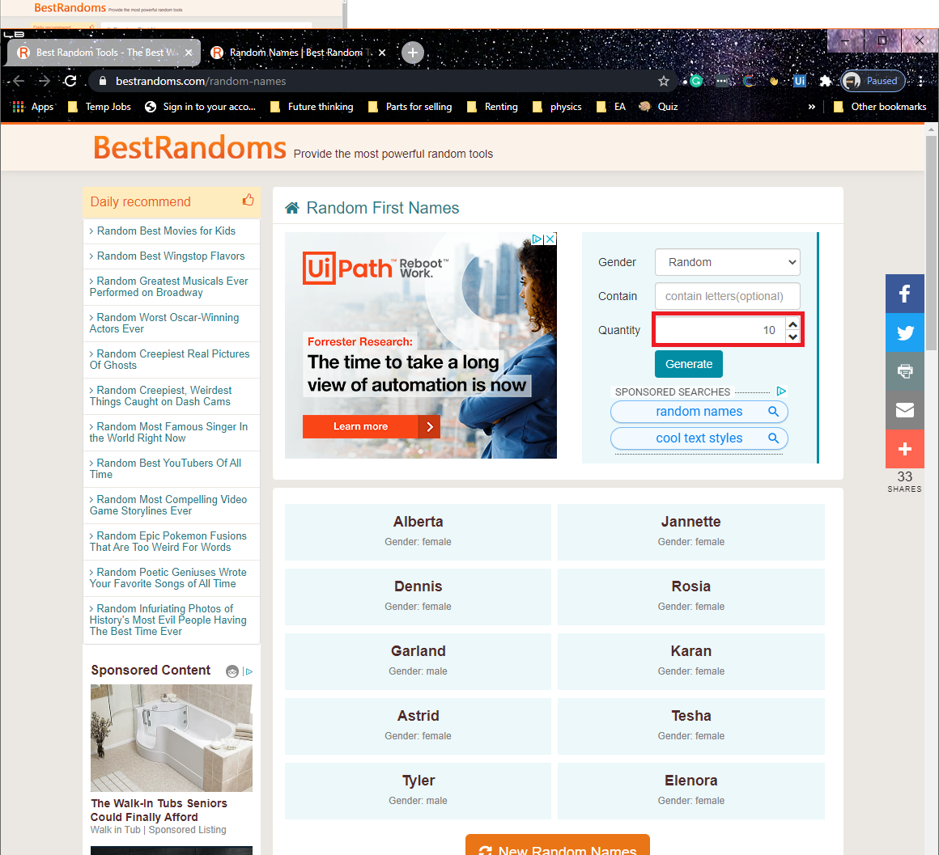

* + Navigate to bestrandoms.com/random-last-names (see below)
  + Type 50 into the quantity
  + Click Generate
  + Copy all the names from the webpage

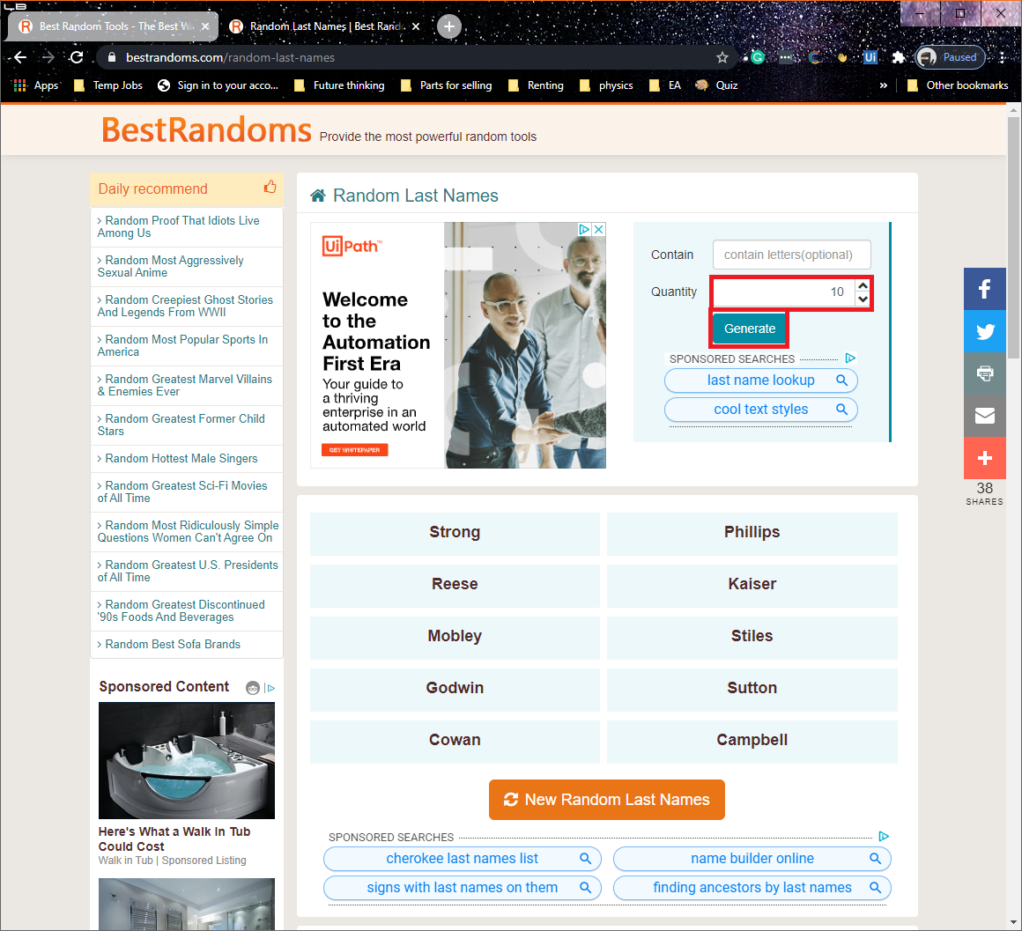

* + Navigate to bestrandoms.com/random-address (see below)
  + Copy all the addresses from the webpage and apply string manipulation to retrieve
  + Click Generate
  + Repeat process until at least 50 addresses are obtained
* Copy and paste all values into a CSV file

### Monitor inbox, create and update user details on database

* Use get Outlook mail message activity on [QATesting545@outlook.com](mailto:QATesting545@outlook.com)



* Iterate through each mailbox item and identify what each message is requesting
  + Move each message to the dedicated folder (“Email automation/create”, “Email automation/update” or “Email automation/delete”)
  + Add each message to the dedicated queue (“create user queue”, “update user queue” or “delete user queue”)

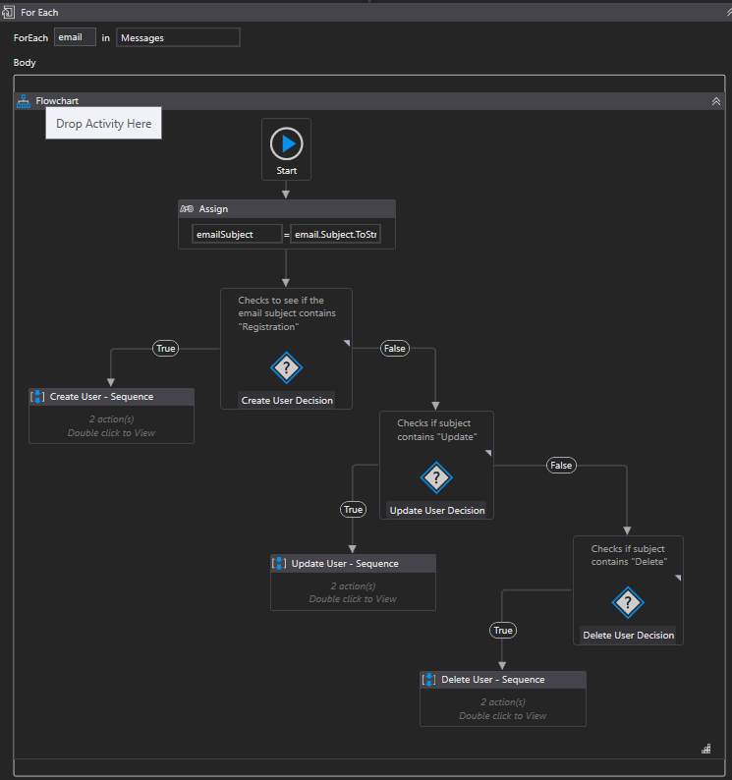

* Invoke three separate workflows that get items from the create, update and delete queues
  + For each workflow modify the user database to make the required changes

### Aggregate content from sites

* Read the file “C:\Users\premal\Google Drive\QAC projects\Email-automation-for-Tobor-users\automation\Aggregation and distribution\config\addregate_config.txt”, it contains the list of websites to be scraped
* For each website in the file, navigate to the website (see below for an example)
* Copy the title of each article, check to see if an article with the same title is stored in the content database
  + if so, then skip to the next article
  + if not, then store the article title, URL, content type (sports, tech or hobbies), website and date retrieved into the content database
  + Repeat the process until 3 articles are stored in the database

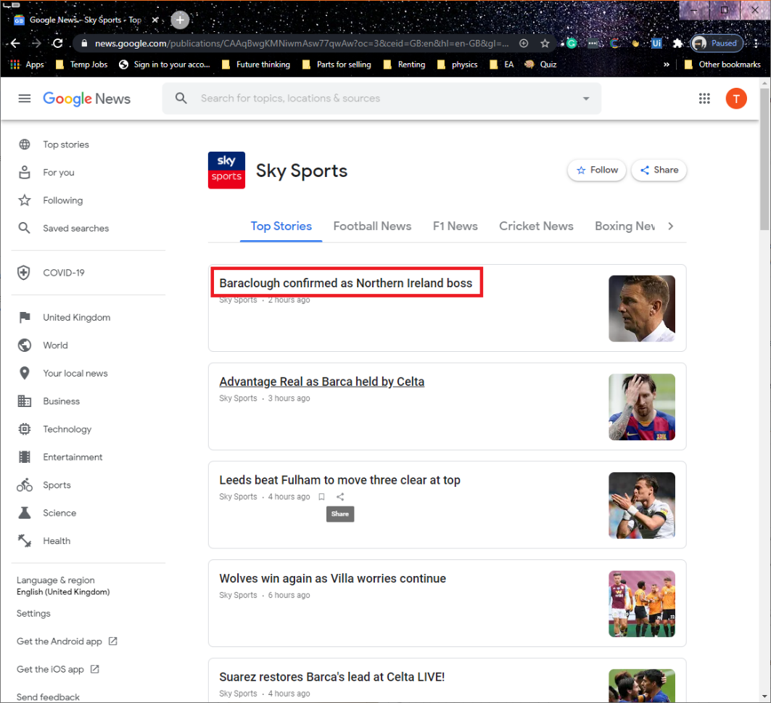

### email to users based on preferences

* Add each user from database to “send user email” queue
  + Add all fields from user database to the specific content of the queue item
* Invoke workflow that can iterate through all the items of “send user email”
  + Check to see if the user wants to receive content on that particular day, using “Interval” field
  + Use the content preferences of the user to filter articles from the content database
  + Use the First Name of the user in greeting email body (Hi {First Name}, have a look…)

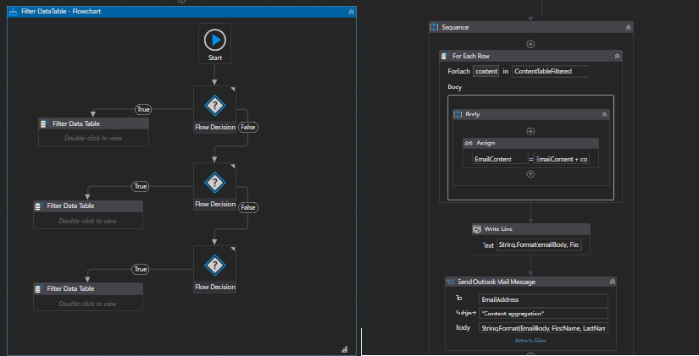

## 4.2 Reporting

### 4.2.1 Business Exceptions

|  |  |
| --- | --- |
| Exception | Solution |
| Email inbox receives an email that does not follow template | Move to special folder for manual intervention |
|  |  |
|  |  |
|  |  |
|  |  |
|  |  |

### 4.2.2 System Exceptions

|  |  |
| --- | --- |
| Exception | Solution |
| Content websites change the format, breaking the web scrape automation | Find alternative website and report error |
| Microsoft.Exchange.Data.Storage.OutboundSpamException | Use an email provider that allows for the mass sending of email using RPA tools or persuade Microsoft that our use of exchange is valid |

### 4.2.3 Performance

Once the processes have successfully completed a performance report and processing log will be emailed to *Roberto* as a pdf file.

**Performance Report**

This will contain all exceptions (business and system) and successes for the automated Process, based on the last automation execution completion (i.e. based on the last time the process ran)

EXAMPLE REPORT

**Processing Log**

This will show cumulative successes from the automated Process:

EXAMPLE REPORT

**CredBest**

**CredBest**

### 4.2.4 Triggers

*Definition of how the Robot will be triggered. This could simply define that this is a manual trigger i.e. an attended start, or could indicate more advanced triggers such as on a particular event or schedule.*

**UPDATE THE TABLE OF CONTENTS AND ENSURE ALL RED TEXT HAS BEEN UPDATED/REMOVED PRIOR TO DISTRIBUTION**